Peter to Rob 25/5/19
The Registration fee was increased from 4d to 6d on 1/10-57 (according to GN 1625, p12). Looking at the Nigeria year books 1960, 61, 65, 66 & 67 this rate prevailed until 1967 where it was listed as 1s (so it probably went up some time during 1966). But why then were the value expressed on the registration envelopes changed from 4d to 9d in 1960? This could be because the first weight class letter rate was included in the price, but on the QEII registration envelopes it was directly stated that “The cost of this envelope does NOT include postage”. This statement was excluded from the subsequent 9d Arms registration envelopes, but these were also from another printer. Furthermore, when that is the case it is often clearly stated on the envelopes, e.g. on Sudan registration envelopes.
In theory the registration fee could have been raised to 9d, and after a short while reduced again to 6d, but that doesn’t seem likely. A more realistic scenario is that the 9d is the buying price for the envelopes, but this doesn’t fit well with the fact that differently sized envelopes are most often priced differently (e.g. in 1947 the price of the 3d size G envelopes was 4½d and for size H2 5d). Later when the fee was raised to 1s they kept producing 9d envelopes until decimalisation in 1973. I have a small note from “Postal Stationery” (journal of the UPSS):
SEPTEMBER-OCTOBER, 1971, Crown Agents:
List of postal stationery items which the Crown Agents Stamp Bureau will order on request. This listing was sent in May to Gordon Morison who forwarded it for publishing in POSTAL STATIONERY.
NIGERIA - Aerograms with 4d, 6d and 9d printed stamps. Registration envelopes selling for ls. 7d and l s.8d.
But were these prices also the local prices (probably since the aerogrammes didn’t come with a mark-up)? In that case a registration fee of 9d would seem out of place but a 1s registration fee gives a ratio between price and fee comparable with the 1947 prices (as do 9d compared to 6d).
So I would be grateful if you could look up in the Post Office Guide:
- The registration fee
- The price of size G, H and H2 registration envelopes (also if there is a discount when buying many)
- Any other information regarding ps registration envelopes
Rob to Peter 30/5/19
Registration is shown as 6d in addition to the appropriate postage. The cost of registration is the same for inland and overseas (but obviously the postage rates differ)
Two sizes of registered letter envelopes were available:
- Size F, at 1s each, or 24s for pack of 24
- Size H, at 1s-1d each, or 26s for pack of 24.
Sizes G and H2 are apparently not available at this date
So 9d is not the buying price of the envelopes, nor is it the current level of registration fee. So, still a puzzle.
Ray to Rob & Peter 31/5/19
I have a couple of internally used KG6 3d envelopes with the same text. They each have 1d added correctly for the internal postage rate. I also have one to Cameroun with 1d, so I assume that rate was the same. My only QE2 internal registered envelope is from Yola to Jos in June 1960, a 4d H2 envelope with 10d added in stamps; I assume that's a 7oz package (2d internal rate + 6x1d per oz + 2d for the increased registration cost). That doesn't help us! As Peter pointed out, by 1963 the internal postage rate was 3d for the standard weight, so 9d would have covered registration + internal mailing. I suppose that someone had the good idea of including the internal postage rate in the stamp, which was the practice in GB at the time (without it being stated on the envelope), but they forgot to tell the printer to change the text!
Rob 31/5/19
If Ray’s theory holds true, international registered letters should have stamps added only to the value of the excess postage over and above the internal standard letter rate. I will have a look at mine.
Yes, as regards postal rates the British Trust Territory of Cameroons was treated as an integral part of Nigeria.
Peter 31/5/19
This is getting complicated….
Firstly, the prices Rob lists would seem excessive with a registration fee of only 6d if the minimum inland postage was not included, so that speaks in favour of the 3d inland postage being included. Ray states that at the time in GB the internal postage was included in the value expressed without it being stated on the envelope, which is perfectly true but it was stated on the later £sd QEII indicium “REGISTRATION AND POSTAGE” (and after decimalisation with the words in reverse order), and earlier on the actual registration fee and postage were separately specified. In Nigeria the only text apart from NINE PENCE is NIGERIA REGISTRATION.
Secondly, the sizes are puzzling. In 1961 all three sizes G, H and H2 were issued. When looking at the Crown Agents archive we sometimes see size G specified as F, and similar H2 specified as just H. The small registration envelopes were previously size F so perhaps the Post Office Guides were not adjusted when the size changed to G in 1960 with the introduction of the QEII 9d envelopes? Also H could mean both H and H2, or perhaps the H2 had been taken off sale at this time? I have a couple used in 1963 but no later examples. In 1965 it was (re-)issued in a new layout.
I believe the mystery stems from the QEII 9d envelopes. When McCorquodale took over the contract from DLR they were apparently told without too many details to adapt the existing indicium to the new situation. They did so by only replacing the Queen’s head in the middle with the Coat of Arms, and keeping the surroundings including the crown (see attached picture). This was not accepted and the crown was omitted before issue. But it could indicate that it was a quite hurried thing amidst the independence without too much discussion on the actual layout and contents of the indicium.
The De La Rue archives on microfilm at The Postal Museum only goes to 1942 (Private Day Books) and 1946 (Correspondence Books), but I wonder whether the physical books extend further than this? It would be nice to see especially the Correspondence Books from 1960, if they exist. At one of my visits, Barry Attoe at The Postal Museum mentioned the possibility of seeing the physical books as some of the microfilms are missing. I will ask him in September how far the physical books extend. Regarding the Crown Agents archives I have seen no correspondence part – only the printings and register of dies etc. Ray, do you know whether any correspondence the Crown Agents had with the printers exist today on microfilm or otherwise?
It would be interesting if Post Office Guides from other years than 1963 could be inspected… Or official gazettes… It seems that every time a question is answered, one or two new ones pop up!
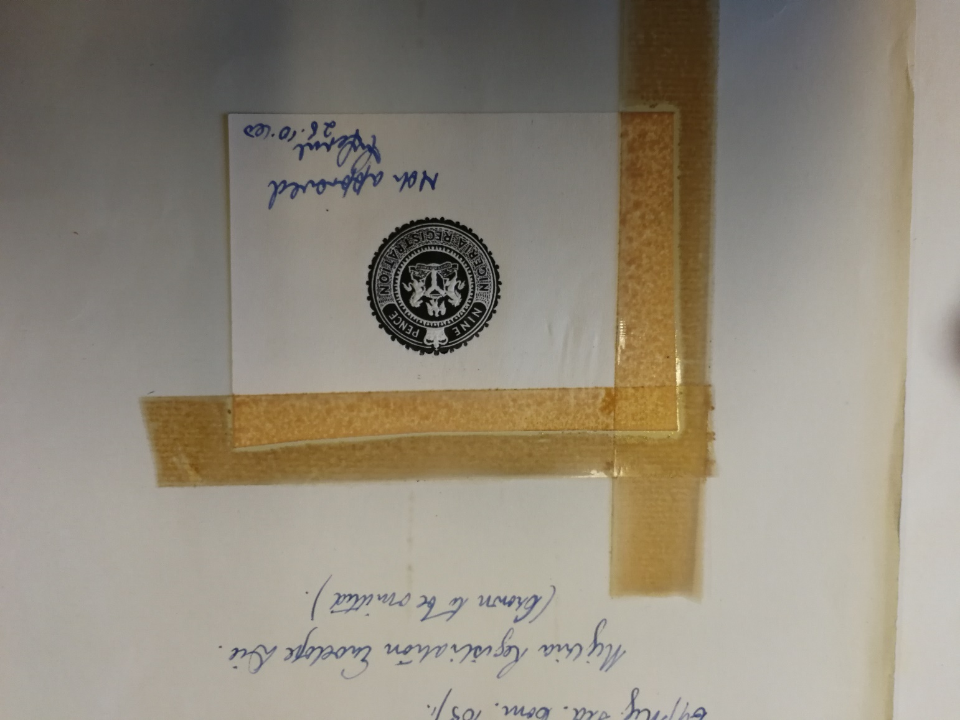

On receiving extract from 1932 PO Guide, Peter 30/4/20
Thank you very much for these pages. Such PO Guides provide many bits of interesting information. In this case I note:
The internal postage rate was 1½d and the imperial rate had gone back to 2d (had been so since 1 October 1931), but why were there only 1d and 1½d envelopes for sale. Well, the last invoice date for 2d envelopes was 21-06-1930, so they had probably sold out by 1933. Regarding the 1d envelopes the last invoice date was 25-08-1931 – just 5 weeks before the rate went up to 1½d rendering the 1d envelopes almost useless. The printing was 40560 so they probably took some time to sell, which also explains that we see such envelopes used as late as 1935-6. I guess the problem of twice changing rates in 1931 (1 April and 1 October) and having redundant envelopes as a result perhaps made the Post Office decide not to continue issuing envelopes?
The other small piece of information concerns postal orders where it is stated : “British Postal Orders (the Orders issued in Nigeria are British Postal Orders overprinted) are issued and paid it…”. At this time and until 1 November 1933 the lowest values 6d – 2/6 had a 1d poundage which was the same as in Britain, so there was technically no need to overprint them. My findings based on the relatively low number of surviving examples show that unoverprinted British postal orders were indeed used, but the latest unoverprinted item recorded from before the poundage went up is from 1930, so in theory there could have been a supply in e.g. 1931 where all values were overprinted.

